Science Homework: Work & Power Due on:

Name: ___________________________ Mark: ________/30

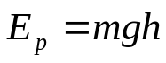 ; 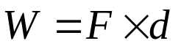; 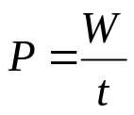; 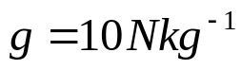

- Complete the following table:

Quantity | Letter | Unit | Abbreviation
Mass | m | kilogram | kg
Work
 | P
 | F |  | N
 |  | kilogram metre per second | kgms⁻¹

(10 marks)
- What is the work done when:
  - A car is pushed 450m by a force of 900N? _____________________________________
_____________________________________(_____)
(2 marks)
  - A bullet is pushed by a force of 1.2kN for 1.8km?
_____________________________________
_____________________________________(_____)
(2 marks)

  - How far can you push a cart if the force is 340N and the work done is 2.5kJ?
_____________________________________
_____________________________________(_____)
(2 marks)
  - What force is required if 1200J of work moves a box 34m?
_____________________________________
_____________________________________(_____)
(2 marks)

  - What is the power output if 4500J of work is done in 1.5s?
_____________________________________
_____________________________________(_____)
(2 marks)
  - How much energy is required for a 120W light to shine for 3 minutes?
_____________________________________
_____________________________________(_____)
(2 marks)
- A man lifts a 23kg bag 1.4m onto a table in 1.6s. Calculate:
  - The work done
_____________________________________
_____________________________________(_____)
(2 marks)
  - The power output
_____________________________________
_____________________________________(_____)
(2 marks)
- A feather is dropped on a calm day, using your knowledge of forces, acceleration and velocity describe its motion as fully as possible. A sketch may help in explaining.

________________________________________________________________________________________________________________________________________________________________________________________________________________________________________________________________________________________________________________________________________________________________________________________________________________________________________________________________________________________________________________________________________________________________________________________________________________________________________________________________________________________________________
(4 marks)

